Exempted errors

These are errors whose effects are cancelled out by the same fielder or a team mate; in other words, the defense succeeds nevertheless inforcing a putout. These errors are consequently not scored against the person who committed them, and are therefore not recorded with any symbol on the score-sheet. They do, however, determine the continuity ofplay in double or triple plays.
NO ERROR IS, according to rule 9.12(d) of the OBR charged against (these are the “exempted errors”):
- the catcher when the catcher, after receiving the pitch, makes a wild throw attempting to prevent a stolen base, unless the wild throw permits the stealing runner to advance one or more extra bases, or permits any other runner to advance one or more bases [OBR9.12(d)(1)].
- any fielder who makes a wild throw if in the scorer’s judgment the runner would not have been put out with ordinary effort by a good throw, unless such wild throw permits any runner to advance beyond the base he would have reached had the throw not been wild [OBR9.12(d)(2)].
- any fielder who makes a wild throw in attempting to complete a double play or triple play, unless such wild throw enables any runner to advance beyond the base such runner would have reached had the throw not been wild [OBR 9.12(d)(3)].
Comment: When a fielder muffs a thrown ball that, if held, would have completed a double play or triple play, the official scorer shall charge an error to the fielder who drops the ball and credit an assist to the fielder who made the throw [OBR 9.12(d) Comment].
- any fielder when, after fumbling a ground ball or dropping a batted ball that is in flight or a thrown ball, the fielder recovers the ball in time to force out a runner at any base [OBR 9.12(d)(4)]. It is completely irrelevant whether it is the same fielder or a different one who makes the putout or assist. In case the misplay has some adverse consequence, an error must be charged.
- A number of misplays apply specifically to the pitcher and catcher. These misplays are not defined as errors but as wild pitches and balks for the pitcher, and passed balls for the catcher [OBR 9.12(e), (f)(1),(2)].

Example 76: The batter hits a deep ground ball to the shortstop who recovers it and bungles his throw to first base.
The official scorer judges that, even if the throw had been perfect, the batter-runner would nevertheless have reached first base safely, and he is awarded a hit.
No errors are charged, because the wild throw had no effect on the outcome of the action.
WBSC |  | Traduction dans l’outil de scorage |  | Outil
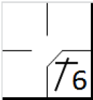 |  | /* Le batteur frappe une balle vers l'arrêt court, qui ne maitrise pas la balle. Le scoreur estime que c'est un hit car, même sans erreur, cela aurait été un hit */  action { batter -> 1B6 } |  | 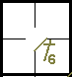

Example 77: With a runner on first base, the batter hits a fly ball to the center fielder, who muffs the catch but recovers the ball in time to put out the runner by throwing to second base.
In this case no error is charged, as the fielder recovered the ball in time to put out the runner in a force play, and them is play had no effect on the outcome of the play.
WBSC |  | Traduction dans l’outil de scorage |  | Outil
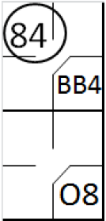 |  | /* Le premier batteur arrive sur base sur un 'base on ball' */  action { batter -> BB }  /* Le deuxième batteur frappe une fly dans le champ centre, qui est relâchée par le défenseur du champ centre. Suite a son erreur, le défenseur récupère la balle et la renvoie a temps vers le défenseur de la deuxième base pour retirer le coureur */  action { batter -> O8 , runner1 -> 84 } |  | 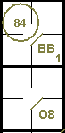

Example 78: With a runner on first and a runner on second,the batter hits a fly ball to the center fielder, who muffs thecatch. The right fielder, standing close by, picks up the ball intime to put out the runner from first by throwing to second base. The runner from second base advances to third base inthis play.
In this case we charge the right fielder with the assist and the second baseman with the put out. As the advance of the runner from second to third was made only for the muffed catch of the ball, an extra base error will be charged to the center fielder. Write a note on the score-sheet to explain this situation.
WBSC |  | Traduction dans l’outil de scorage |  | Outil
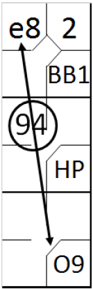 |  | /* Le premier batteur arrive sur base sur un 'base on ball' */  action { batter -> BB }  /* Le second batteur est touché par un lancé, il gagne la première base, le coureur avance */  action { batter -> HP, runner1 -> + }  /* le batteur frappe une fly dans le champ centre, le défenseur laisse tomber la balle. Le défenseur du champs droit récupère la balle a temps et la renvoi au défenseur de la deuxième base pour retirer le coureur venant de la première base */  action { batter -> O9, runner1 -> 94 , runner2 -> e8 } |  | 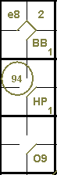

Example 79: with a runner on third base and less than two out, the batter hits a foul fly to the left field. The left fielder deliberately drops the ball, to prevent the runner from third to score after the catch. The batter remains at bat, without the scorer writing down the 'catching error'.
WBSC |  | Traduction dans l’outil de scorage |  | Outil
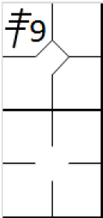 |  | /* Le premier batteur frappe un triple dans le champ droit */  action { batter -> 3B9 }  /* le deuxième batteur frappe une fly dans le champ gauche dans la zone des fausses balles. Le défenseur préfère laisser tomber la balle pour éviter que le coureur ne marque un point */ |  | 